K L UNIVERSITY
FRESHMAN ENGINEERING DEPARTMENT

A Project Based Lab Report On
EMI MASTER – LOAN CALCULATOR & PREPAYMENT SIMULATOR (EMIM-LCPS)

SUBMITTED BY:
ID NUMBER NAME
2500030677 A. Nanda Kishore
2500030995 K. Sai Koushik
2500031064 P. Akshaya
2500031098 M. Karthik

UNDER THE ESTEEMED GUIDANCE OF Dr. N. SREERAM
ASSOCIATE PROFFESSOR


KL UNIVERSITY
Green fields, Vaddeswaram – 522 502 Guntur Dt., AP, India.

DEPARTMENT OF BASIC ENGINEERING SCIENCES



CERTIFICATE
.
This is to certify that the project based laboratory report entitled “EMI MASTER – LOAN CALCULATOR & PREPAYMENT SIMULATOR” submitted by A. Nanda Kishore, K.Sai Koushik, P. Akshaya, M. Karthik bearing Regd. Nos. 2500030677, 2500030995, 2500031064, 2500031098, etc., to the Department of Computer Science Engineering, KL University, in partial fulfillment of the requirements for the course Python Programming(25SC2007) in I B.Tech II Semester, is a bonafide record of the work carried out under my supervision during the academic year 2025–2026.

PROJECT SUPERVISOR HEAD OF THE DEPARTMENT Dr. N. SREERAM Dr. HARITHA

ACKNOWLEDGEMENTS

It is great pleasure for me to express my gratitude to our honorable President.

Sri. Koneru Satyanarayana, for giving the opportunity and platform with facilities in accomplishing the project-based laboratory report.
I express sincere gratitude to our Director Dr. A. Jagdeesh for his administration towards our academic growth.
I express sincere gratitude to our Coordinator and HOD-BES Dr. D. Haritha for her leadership and constant motivation provided in successful completion of our academic semester. I record it as my privilege to deeply thank you for providing us with the efficient faculty and facilities to make our ideas into reality.
I express my sincere thanks to our project supervisor Dr. N. SREERAM for his novel association of ideas, encouragement, appreciation, and intellectual zeal which motivated us to venture this project successfully.
Finally, we are pleased to acknowledge our indebtedness to all those who devoted themselves directly or indirectly to making this project a success.

Name: A. Nanda Kishore
K. Sai Koushik
P. Akshaya
M. Karthik

ID No: 2500030677
2500030995
2500031064
2500031098

ABSTRACT

The EMI MASTER – Loan Calculator & Prepayment Simulator is designed to help individuals better understand loans, EMIs, and interest calculations, which are often difficult to interpret using traditional tools. Many existing solutions provide only the final EMI value without explaining the underlying calculations, leading to a lack of transparency and limited financial awareness. This project addresses that gap by offering detailed EMI calculations along with a clear breakdown of how each payment is divided between principal and interest throughout the loan tenure. By doing so, it enables users to gain a deeper insight into how loans actually work over time.

In addition to basic calculations, the system allows users to simulate prepayments, helping them understand how making extra payments can significantly reduce the overall interest burden and shorten the repayment period. It also generates well-structured amortization tables that track the loan balance and payment distribution at each stage. Furthermore, the project enhances user understanding by visualizing financial trends through graphs using tools like Matplotlib, making complex data more intuitive and easier to analyze. It also encourages users to experiment with different loan parameters such as interest rates and tenure to compare multiple scenarios effectively. By combining programming logic with financial concepts, EMI MASTER not only serves as a practical tool but also as an educational platform that promotes financial literacy and supports better decision-making.

Keywords: EMI, Loan, Interest, Prepayment, Simulator, Python

INDEX

S.NO | TITLE | PAGE NO
1 | Introduction | 6
2 | Aim of the Project | 7
2.1 | Advantages & Disadvantages | 8
2.2 | Future Implementation | 8
3 | Software & Hardware Details | 9
4 | Data Flow Diagram | 10
5 | Algorithm for each module | 11=12
6 | Implementation | 13-15
7 | Integration and System Testing | 16-19
8 | Conclusion | 20

INTRODUCTION
In today’s world, many people take loans for education, houses, vehicles, and personal needs. However, understanding how loans work—especially EMI, interest, and repayment—is often confusing. Most users do not clearly know how their monthly payment is divided between principal and interest.
Although many online EMI calculators are available, they only give final results and do not explain the complete breakdown. Because of this, users cannot fully understand how their loan changes over time or how decisions like prepayment can help reduce interest.
To solve this problem, the project EMI MASTER – Loan Calculator & Prepayment Simulator is developed. This system provides:
- Accurate EMI calculation
- Clear split of principal and interest
- Amortization table showing monthly loan details
- Prepayment simulation to analyze savings
- Basic visual representation of loan trends
This project helps users understand loans in a simple and transparent way. It also applies programming concepts to solve real-life financial problems, making it useful for both learning and practical use.

AIM

The main aim of this project is to develop a system that helps users understand and manage loans effectively. It focuses on providing accurate EMI calculations, analyzing repayment structures, and allowing users to explore different financial scenarios. The system is designed to simplify loan-related decisions and improve overall financial awareness through automation and clear insights.

The project aims to:
- Calculate EMI accurately based on user inputs
- Simulate prepayment strategies to reduce interest burden
- Compare different loan scenarios for better decision-making
- Improve financial awareness among users
- Automate loan analysis in a simple and efficient way

ADVANTAGES
- Accurate EMI Calculations: Provides precise EMI results based on correct financial formulas.
- Saves Time and Effort: Performs calculations instantly, avoiding manual work.
- Provides Financial Insights: Helps users understand interest and loan repayment clearly.
- Helps in Decision Making: Supports comparing options for better financial choices.
- Visual Representation of Data: Displays loan details using simple graphs and charts..

DISADVANTAGES

Requires Basic Financial Knowledge: Users need some understanding of loan and EMI concepts.

Needs Python Environment: The system requires Python and necessary libraries to run.

Slightly Complex for Beginners: Beginners may find it a bit difficult to understand initially.

FUTURE IMPLEMENTATION

In future, the system can be developed as a mobile app and web application for better accessibility. Features like AI-based loan suggestions and real-time bank integration can also be added to improve its functionality and user experience.

SYSTEM REQUIREMENTS

SOFTWARE REQUIREMENTS:
The major software requirements of the project are as follows: Language: Python programming language.
Operating system: Windows 10 or more /Linux/Mac.
Technical requirements: Monitor, CPU, Keyboard, Mouse, etc...

HARDWARE REQUIREMENTS:
The hardware requirements that map towards the software are as follows: RAM: 8 GB.
Processor: i5/i7.

DATA FLOW DIAGRAM

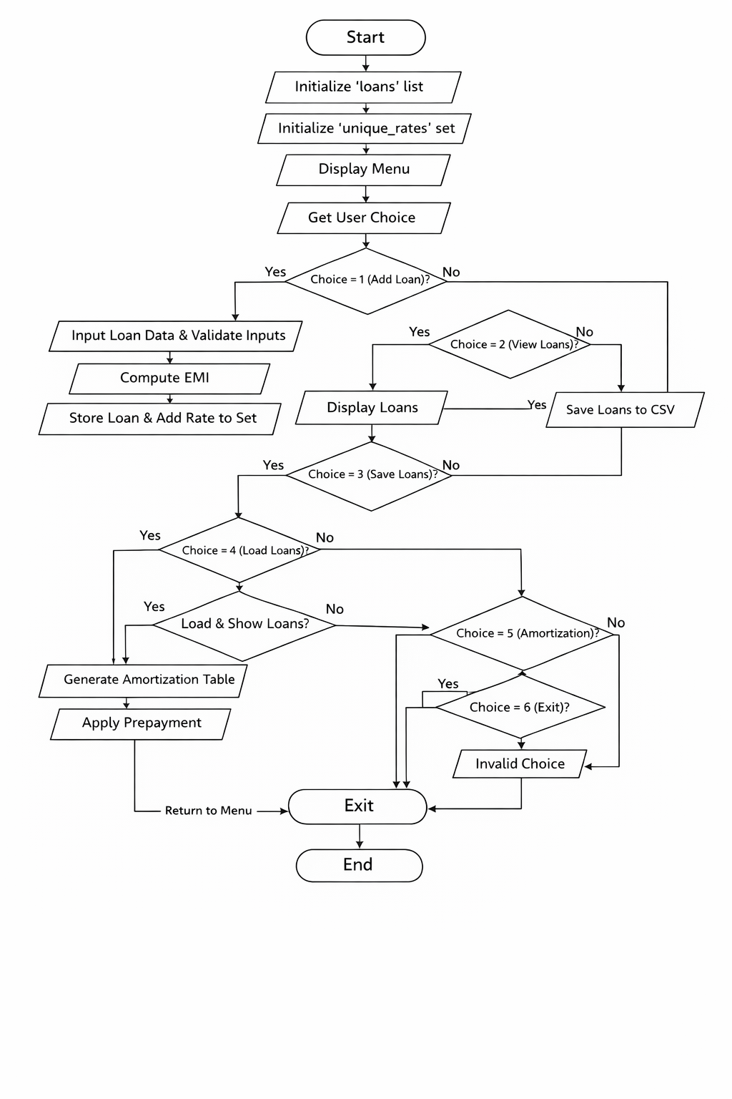
ALGORITHM

Step 1: Start the program.

Step 2: Initialize an empty list loans.

Step 3: Initialize an empty set unique_rates.

Step 4: Display the menu options:

Add Loan

View Loans

Save Loans

Load Loans

Amortization Table

Apply Prepayment

Exit

Step 5: Accept user choice.

Step 6: If choice = 1 (Add Loan):
Step 6.1: Input loan amount, interest rate, and tenure.
Step 6.2: Validate inputs.
Step 6.3: If invalid, display error.
Step 6.4: Else compute EMI.
Step 6.5: Create loan object.
Step 6.6: Store loan in list.
Step 6.7: Add rate to set.

Step 7: Else if choice = 2 (View Loans):
Step 7.1: If no loans, display message.
Step 7.2: Else display all loan details.

Step 8: Else if choice = 3 (Save Loans):
Step 8.1: Save all loans into CSV file.

Step 9: Else if choice = 4 (Load Loans):
Step 9.1: Load and display loans from CSV file.

Step 10: Else if choice = 5 (Amortization):
Step 10.1: Select loan.
Step 10.2: Generate amortization table.
Step 10.3: Display results.

Step 11: Else if choice = 6 (Prepayment):
Step 11.1: Select loan.
Step 11.2: Enter prepayment amount.
Step 11.3: Update loan and recalculate EMI.
Step 11.4: Display updated loan.

Step 12: Else if choice = 7 (Exit):
Step 12.1: Terminate the program.

Step 13: Else display "Invalid choice".

Step 14: Repeat steps from menu until exit is selected.

Step 15: Stop.

IMPLEMENTATION

import csv
import pandas as pd
class InvalidLoanError(Exception):
pass
def compute_emi(P, R, N):
r = R / 1200
return (P * r * (1 + r)**N) / ((1 + r)**N - 1)
def validate_inputs(P, R, N):
if P <= 0:
raise InvalidLoanError("Loan amount must be positive")
if R <= 0:
raise InvalidLoanError("Interest rate must be positive")
if N <= 0:
raise InvalidLoanError("Tenure must be positive")
class Loan:
def __init__(self, principal, rate, tenure):
validate_inputs(principal, rate, tenure)
self.principal = principal
self.rate = rate
self.tenure = tenure
self.emi = compute_emi(principal, rate, tenure)
def summary(self):
return (self.principal, self.rate, self.tenure, self.emi)
def display(self):
print(f"\nLoan: {self.principal}")
print(f"Rate: {self.rate}%")
print(f"Tenure: {self.tenure} months")
print(f"EMI: {self.emi:.2f}")
class Prepayment(Loan):
def apply_prepayment(self, amount):
if amount > self.principal:
raise InvalidLoanError("Prepayment exceeds loan")
self.principal -= amount
self.emi = compute_emi(self.principal, self.rate, self.tenure)

def save_loan_to_csv(loan):
with open("loans.csv", "a", newline='') as f:
writer = csv.writer(f)
writer.writerow(loan.summary())

def load_loans_from_csv():
try:
with open("loans.csv", "r") as f:
reader = csv.reader(f)
print("\nSaved Loans:")
for row in reader:
print(row)
except FileNotFoundError:
print("No saved data found.")

def generate_amortization(loan):
data = []
balance = loan.principal
r = loan.rate / 1200
emi = loan.emi

for month in range(1, loan.tenure + 1):
interest = balance * r
principal = emi - interest
balance -= principal

data.append([month, principal, interest, max(balance, 0)])

df = pd.DataFrame(data, columns=["Month", "Principal", "Interest", "Balance"])
return df

loans = []
unique_rates = set()
def main():
while True:
print("\n====== EMI MASTER ======")
print("1. Add Loan")
print("2. View Loans")
print("3. Save Loans")
print("4. Load Loans")
print("5. Amortization Table")
print("6. Apply Prepayment")
print("7. Exit")

choice = input("Enter choice: ")
try:

if choice == "1":
P = float(input("Loan Amount: "))
R = float(input("Interest Rate (%): "))
N = int(input("Tenure (months): "))

loan = Loan(P, R, N)
loans.append(loan)
unique_rates.add(R)

print("Loan added successfully!")

elif choice == "2":
if not loans:
print("No loans available.")
for loan in loans:
loan.display()
print("Unique Rates:", unique_rates)

elif choice == "3":
for loan in loans:
save_loan_to_csv(loan)
print("Saved to CSV.")

elif choice == "4":
load_loans_from_csv()

elif choice == "5":
if not loans:
print("No loans to analyze.")
continue

index = int(input("Select loan index (0-based): "))
df = generate_amortization(loans[index])
print(df.head(12)) # show first year

elif choice == "6":
index = int(input("Select loan index: "))
amount = float(input("Prepayment amount: "))

prepay = Prepayment(
loans[index].principal,
loans[index].rate,
loans[index].tenure
)

prepay.apply_prepayment(amount)
prepay.display()
elif choice == "7":
print("Exiting EMI MASTER...")
break

else:
print("Invalid choice.")

except Exception as e:
print("Error:", e)
if __name__ == "__main__":
main()

INTEGRATION AND SYSTEM TESTING OUTPUTS

Screen Shots:

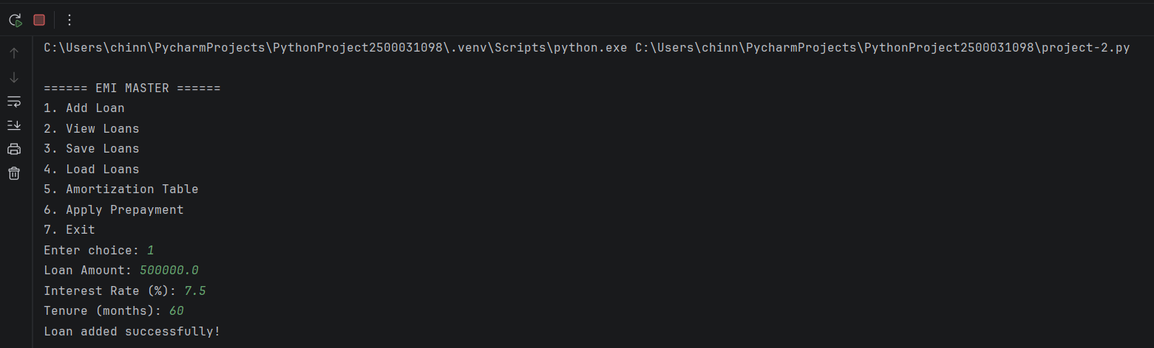

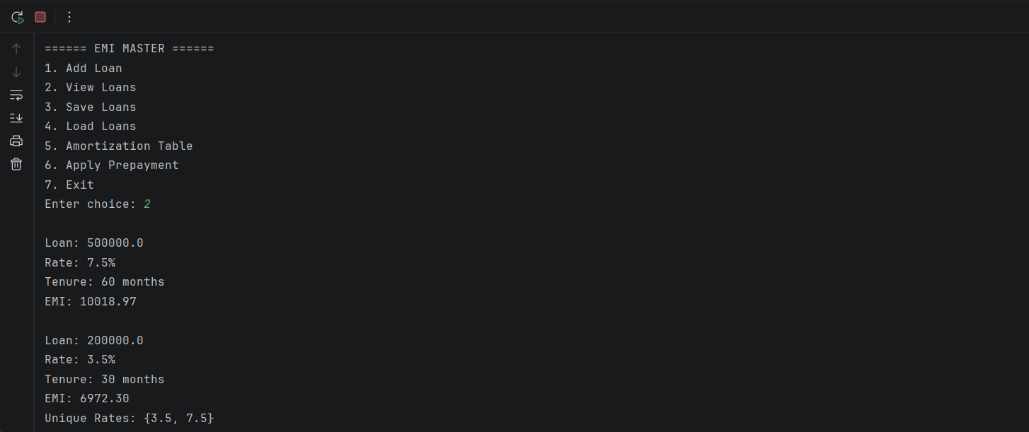
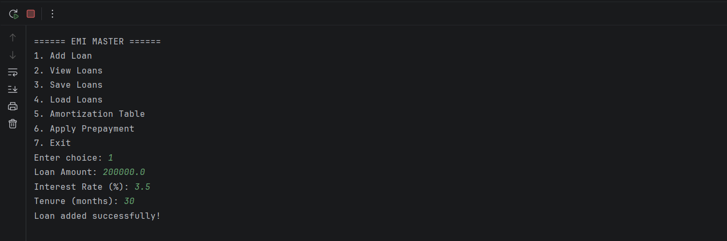

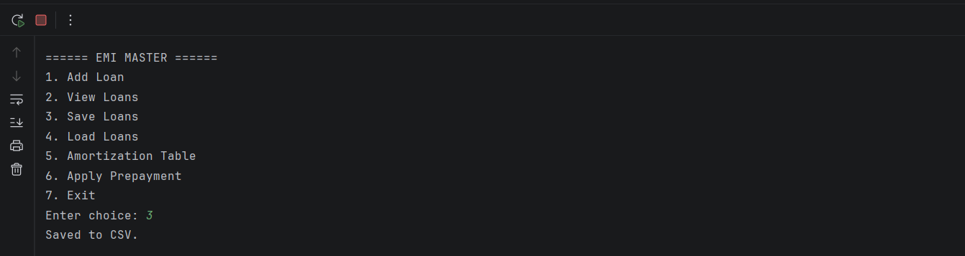

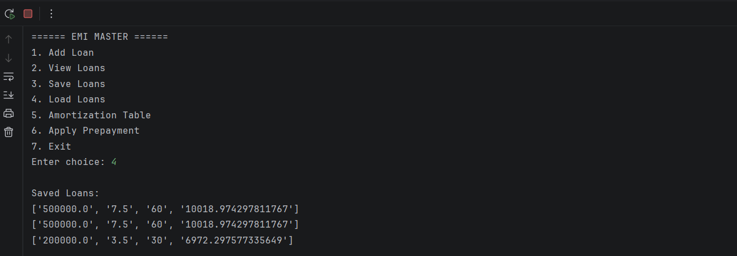
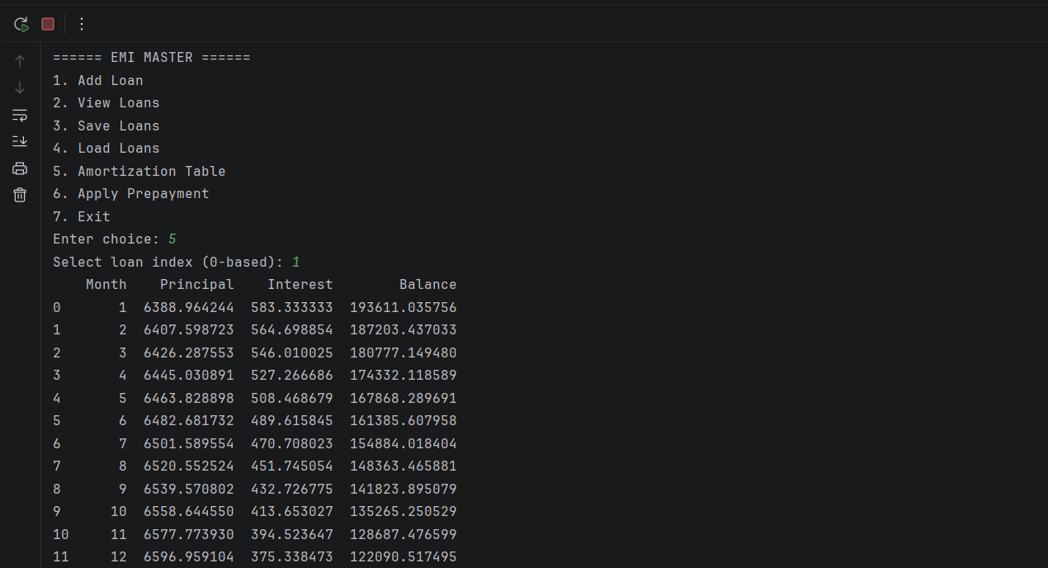

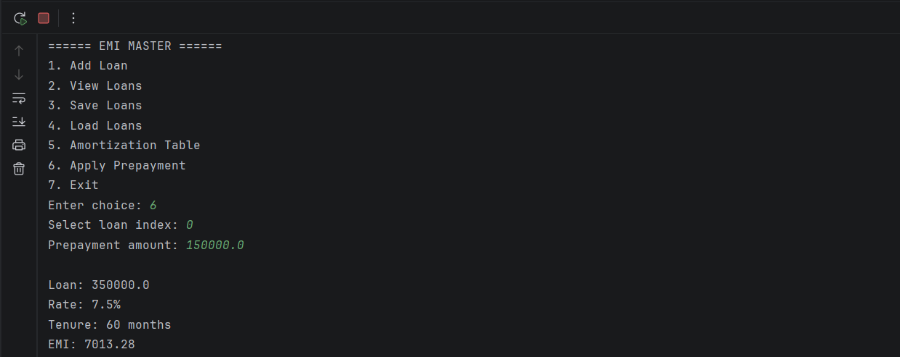
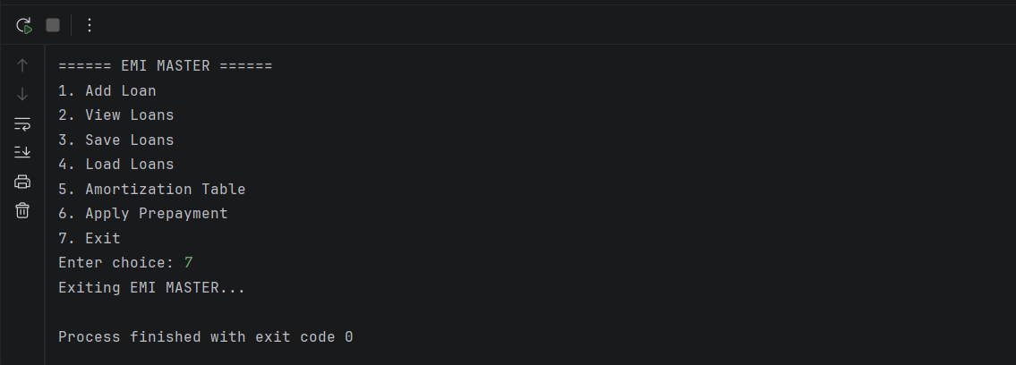

CONCLUSION

The EMI MASTER system was successfully developed and tested. It provides a clear understanding of loan structures and financial planning.
This project enhances both:
- Programming skills
- Financial literacy

